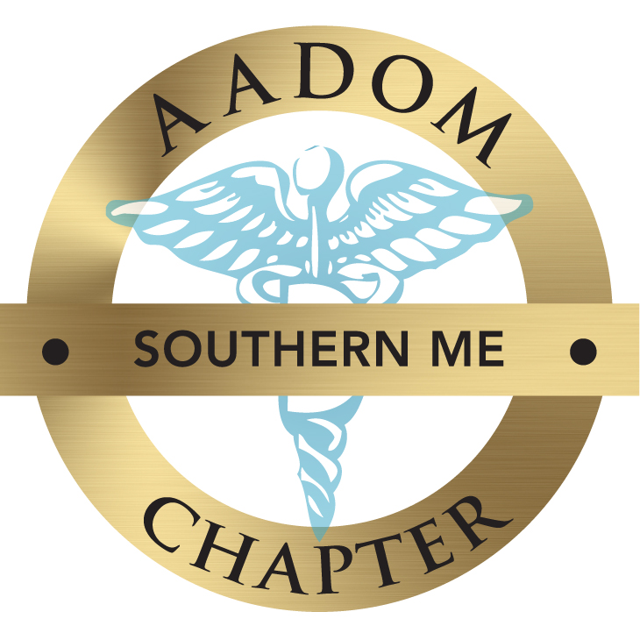

Welcome!

We are excited to extend an invitation for you and the dental team to join our AADOM Southern Maine Chapter. The mission of our chapter is to provide networking, education and up to date information on the day-to-day tasks, topics and challenges front office and clinical dental staff face. Our agenda will include round table discussions and speakers presenting on the hot topics and current issues as well positive open group discussions.

The meetings will be held at the York County Pediatric Dentistry & Harborside Dental’s team lounge location of 1750 Post Road – Wells, ME 04090 ( 4 minutes off RT95 / Wells Exit ) or via ZOOM.

Networking 5:30PM-6:00PM Meeting 6:00pm -8:00 PM ( unless noted )

We are always looking for additional sponsors so we can continue to bring as many fabulous speakers & courses as possible! Feel free to contact me with any leads.

Please feel free to contact
Stacey Singleton, CDA, EFDA, FAADOM – Chapter President
somaineaadom@gmail.com , or call 207-608-1692

We are always looking for Sponsors – please spread the word !!!

2022 Board Members : Stacey Singleton, President
Karen Bravo, Vice President
Kari Peterson, Treasurer
Camilla Mozo & Kelly Lynch – Co- Secretaries
Christine Auger – Public Relations Coordinator

We look forward to having you part of our dental management community. We anticipate a strong support system for all members of the dental practice.

Tuesday – June 7th 6:00 – 7:00 pm ( Hybrid )
Boost Hygiene Production - Speaker : Heidi Giasson, RDH
Endo Assoc. 82 Coyle St- Portland, ME & ZOOM
Learn how to boost hygiene production through the non-surgical periodontal program and myofunctional therapy.
Tuesday - July 26th 6:00 – 8:00 pm
Summer Luau Sizzler
YCPD/Harborside 1750 Post Road – Wells 6:00 – 8:00 pm
Networking & Good Food; relax and enjoy hot topics, frustrations, protocols, ….
Tuesday- August 9th 6:00 – 8:00 pm ( Hybrid )
The 10 "KNOWS" to get to YES Speaker: Kelly Lynch, MAADOM
YCPD/Harborside 1750 Post Road – Wells, ME
The 10 "KNOWS" to get to YES will help you elevate your practice levels of communication, treatment acceptance, team synergy and patient care! Watch your practice thrive as you build loyal and lasting relationships with your patients. Seeing dentistry through the eyes, hearts and minds of your patient is paramount to helping everyone in the practice understand and meet their wants and needs. Whether you are a new practice looking for the keys to growth or you are an established practice wanting to stay ahead of the ever-growing challenges and changes in patient care; you need to know about the 10 "KNOWS" to get to YES! Each attendee will get Kelly’s book😊
Tuesday – September 13th 6:00 - 7:00 pm HR Fundamentals ( ZOOM ONLY )
Speaker : Rick Garofalo from The Practice Mechanic
Learn immediately implementable Human Resource Fundamentals. Interactive ability to ask questions on pressing questions. Review office manuals, new hire expectations and obstacles.
Friday October 21st 9:00 am – 12:30 pm – The Wild World of Dental Insurance
Speaker : Teresa Duncan ( Hybrid )
YCPD/Harborside 1750 Post Road – Wells, ME
Are you stressed out with PPOs, leased networks, and patient objections? You are not alone. Managers and insurance coordinators face an increasingly complex insurance landscape. This discussion will help you prepare by explaining the why and how of these industry shifts. Offices that are aware of these changes before they are put into effect will weather the storm just fine. Will you be one of them? We will also review ways to improve your insurance systems. How should you handle eligibility and benefit issues? What about denials and disallows? Let’s talk about ways to manage this very part of your revenue cycle!
Tuesday – December 13th A New Years Resolution of Empowerment.
Speaker : Dr. Taryn MacCarthy 6:00 – 8:00 pm
YCPD/Harborside 1750 Post Road – Wells, ME
This is a hands-on two hour workshop to create the vision for the most empowered version of you in 2023! During our workshop you will be guided on a journey of self discovery and self exploration to understand what your inner being is calling of you and how to elevate yourself in all aspects of your life. We will create a vision for health, wealth, and love and for personal inner fulfillment that will guide you to live to your greatest potential in 2023!
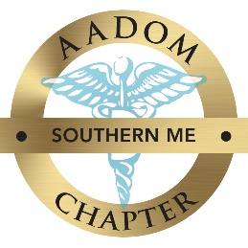

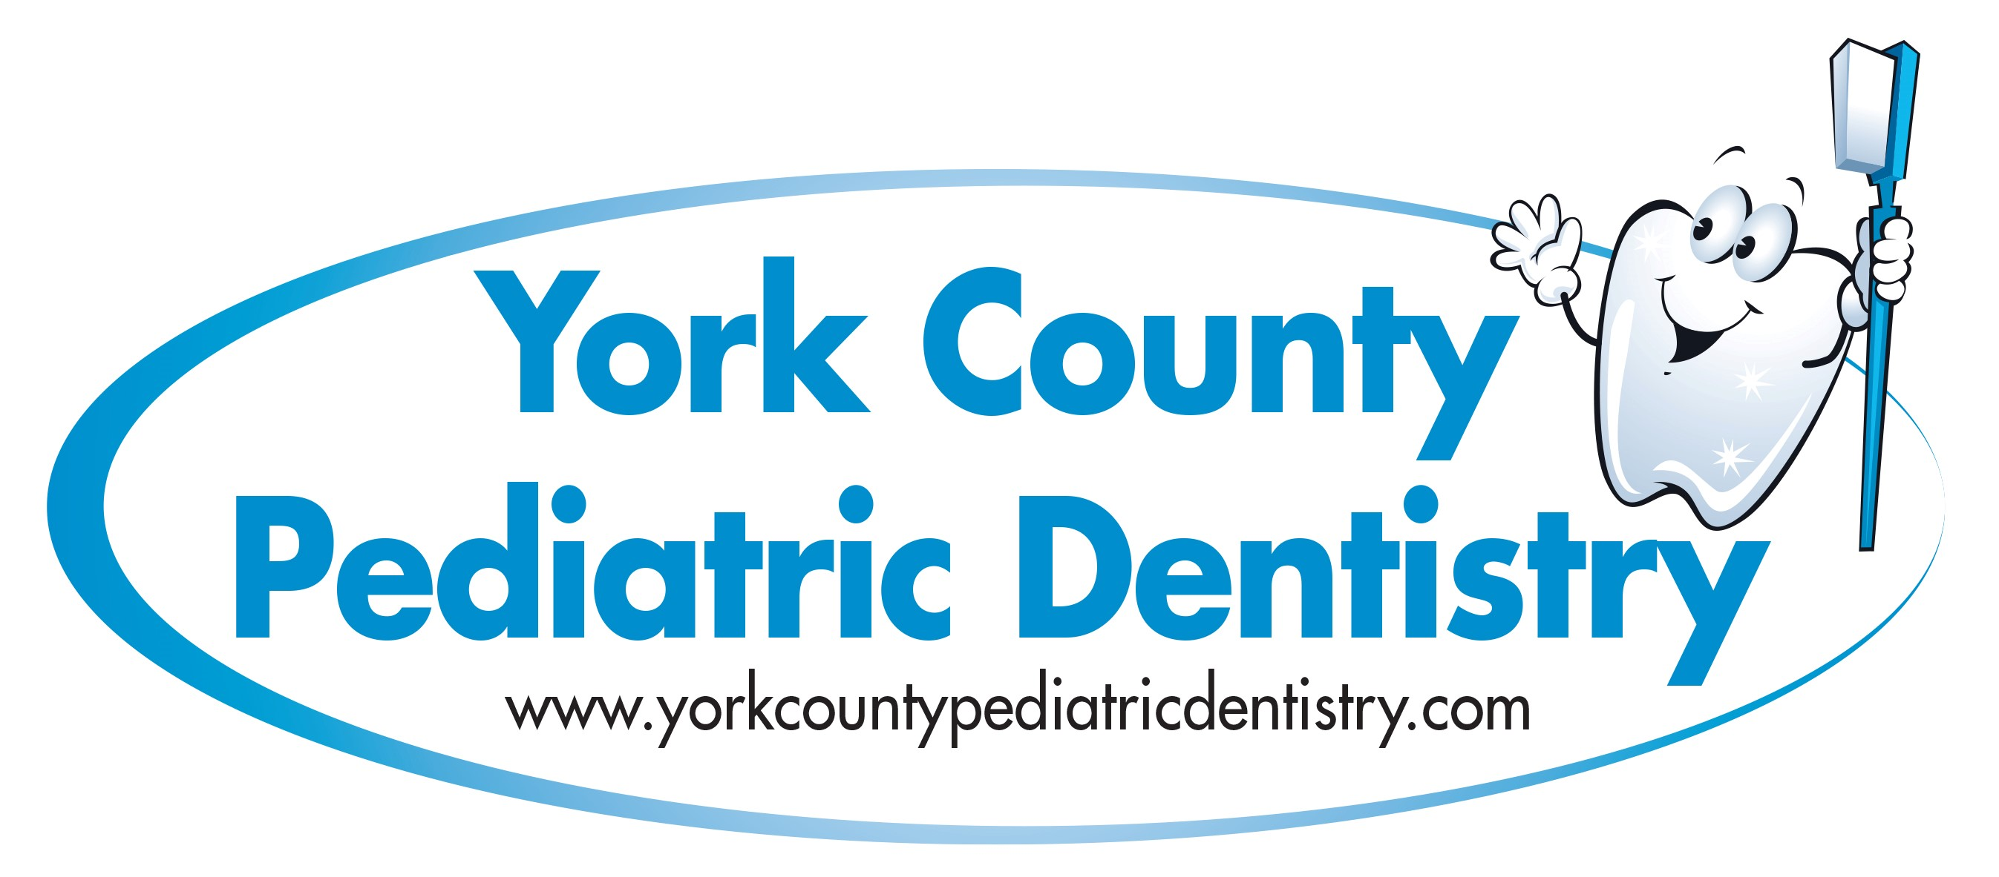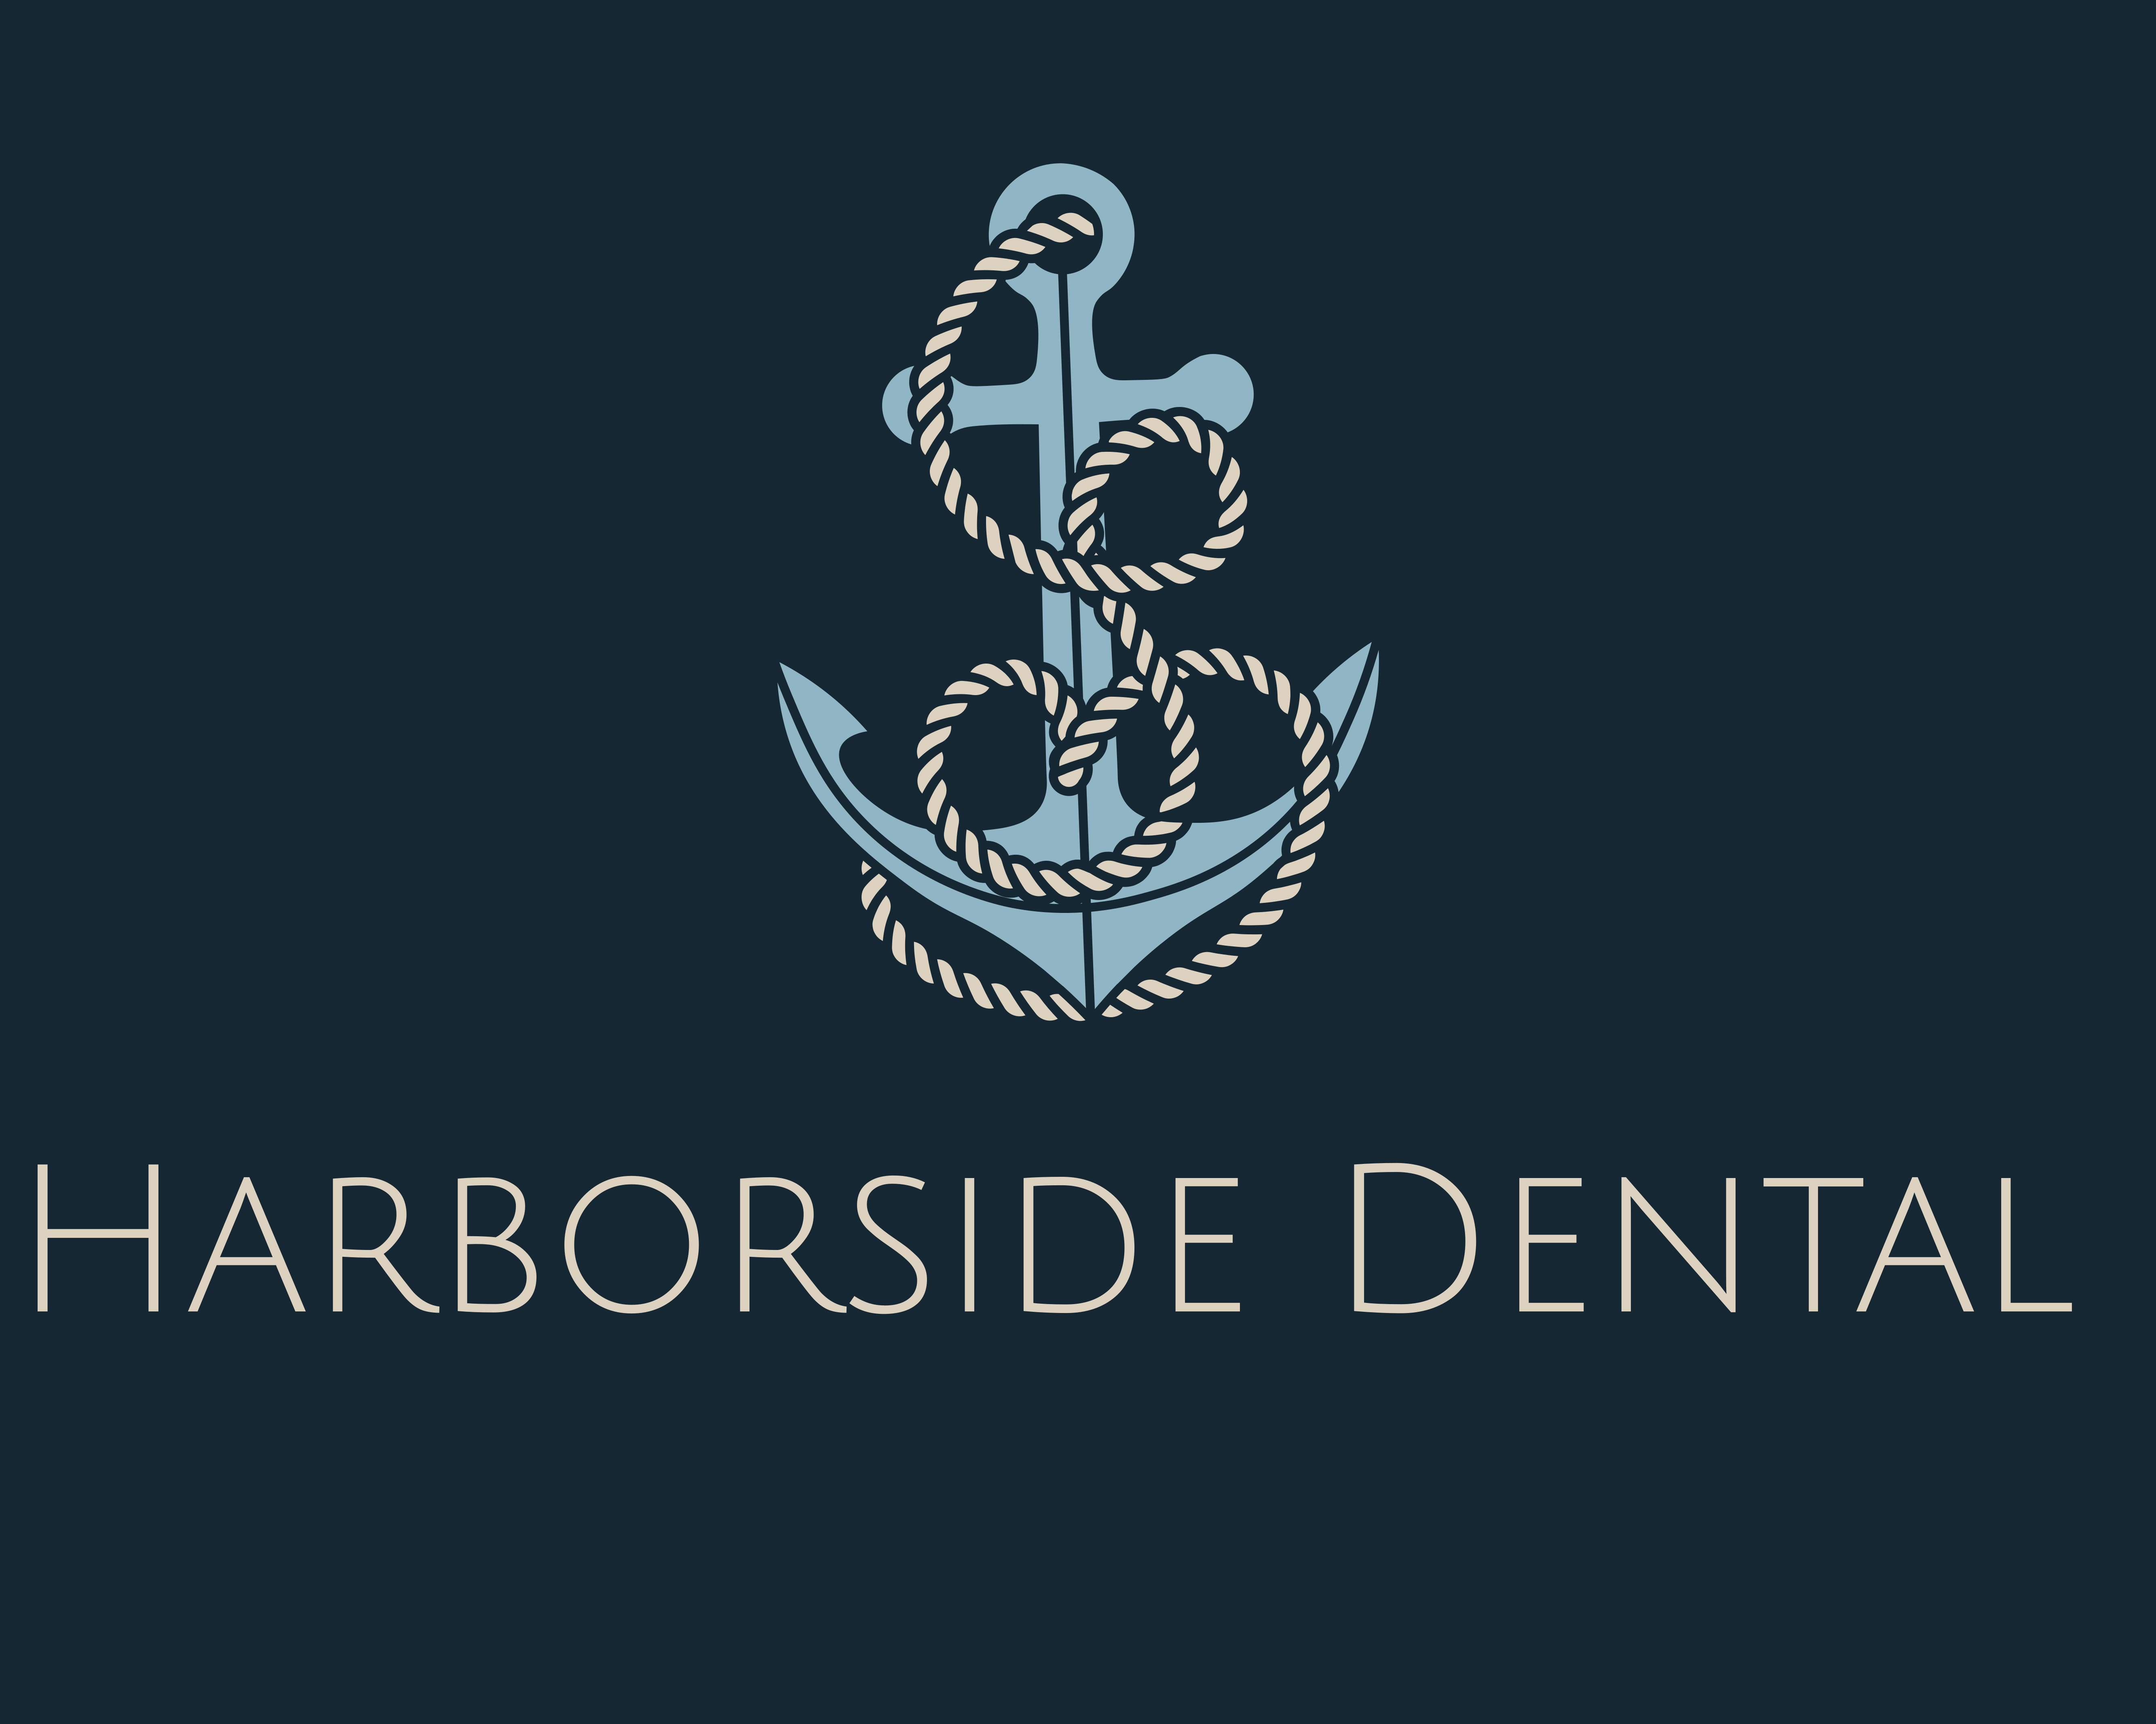

THANK YOU TO OUR 2022 SPONSORS!



